**Magento Taxes: Configuration, Storage, and Retrieval**

**Magento Tax System**

* **Magento 2** is a robust e-commerce platform that allows store owners to manage various aspects of their online store, including tax calculations.
* Proper tax management ensures compliance with local laws and provides accurate pricing to customers.

**Tax Rules:**

* Define how taxes are applied based on location, product type, and customer groups.

**Tax Rates:**

* Specific percentages applied to the taxable amount.

**Tax Classes:**

* Categorize products and customers to determine applicable tax rules.

**Tax Zones and Rates:**

* Geographic areas with specific tax rates.

**Difference Between Tax rule and Tax zone&rates**

|  |  |
| --- | --- |
| **Tax Rules** | **Tax Zones & Rates** |
|  |  |
| Combines tax rates, product, and customer classes. | Defines tax rates based on location (zones). |
| Determines how tax is applied to products and customers. | Sets tax percentage for specific regions (countries/states). |
| A rule links the tax rate to product types and customer groups. | Tax zones refer to the geographic areas where taxes apply. |
| Example: "VAT for retail customers." | Example: 10% tax for New York state. |

**Tax Configuration in Magento:**

* Configuring taxes in Magento involves setting up tax zones and rates, defining tax rules, and assigning these rules to products and customer groups.
* Setting Up Tax Zones and Rates
* Tax **Zones** define the geographical areas where specific tax rates apply.
* **Tax Rates** specify the percentage of tax applied.
* **Navigate to Tax Zones and Rates:**

0 Admin Panel > Stores > Taxes > Tax Zones and Rates.

* **Add New Tax Rate:**

0 Click on "Add New Tax Rate".

0 Fill in the Tax Identifier (e.g., "GST").

0 Enter the Tax Title.

0 Specify the Tax Rate (percentage).

0 Define the Tax Country, State, and ZIP/Postcode as per requirements.

0 Save the tax rate.

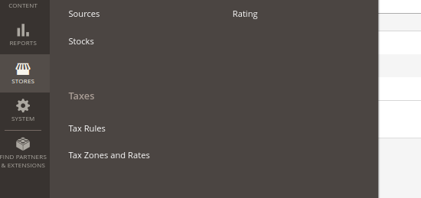

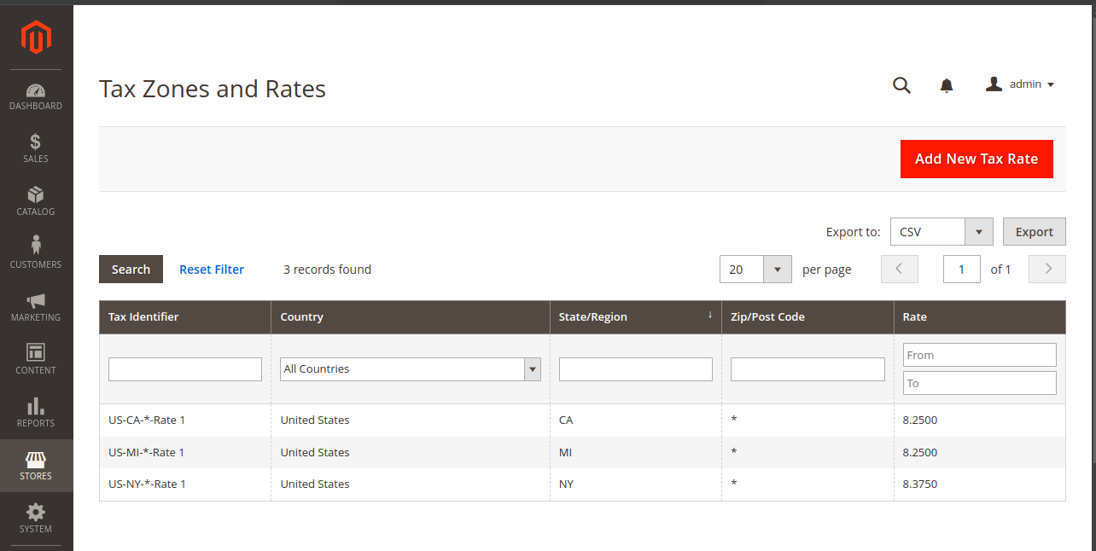

**Tax Rules**

* Tax Rules combine tax rates with product tax classes and customer tax classes to apply the correct tax.
* Steps to Create a Tax Rule:
* **Navigate to Tax Rules:**
  + Admin Panel > Stores > Taxes > Tax Rules.
* **Add New Tax Rule:**
  + Click on "Add New Tax Rule".
  + Enter the Rule Name.
  + Assign Customer Tax Classes (e.g., Retail Customer).
  + Assign Product Tax Classes (e.g., Taxable Goods).
  + Select the applicable Tax Rates.
  + Save the tax rule.

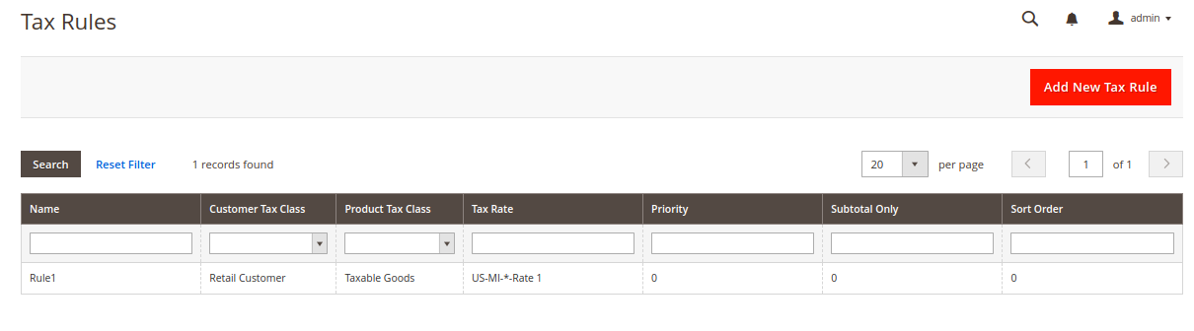

**Applying Taxes to Products and Customer Groups**

* Assign appropriate tax classes to products and customer groups to ensure taxes are applied correctly during checkout.
* **Assigning Tax Classes to Products:**
  + Edit a product and under the "Tax Class" dropdown, select the relevant tax class.
* **Assigning Tax Classes to Customer Groups:**
  + Admin Panel > Customers > Customer Groups.
  + Edit a group and assign the desired customer tax class.

**Storage of Tax Information in Magento**

* Magento stores all tax-related data in its **database**.
* **tax_calculation:** Stores tax calculation rules.
* **tax_calculation_rate:** Contains tax rate details.
* **tax_calculation_rule:** Defines tax rules.
* Sales_order: order level tax details

**Table structure**

**tax_calculation_rate**  : Contain tax rates details

|  |  |
| --- | --- |
| **Column Name** | **Description** |
|  |  |
| tax_calculation_rate_id | Unique identifier for the tax rate |
| code | Tax code (e.g., GST) |
| rate | Tax percentage |
| zip_is_range | Indicates if ZIP codes are in a range |
| tax_country_id | Country code (e.g., CA for Canada) |
| tax_postcode | Specific postal code or pattern |

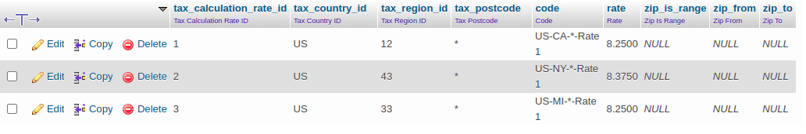

**tax_calculation**  : Stores tax calculation rules

|  |  |
| --- | --- |
| **Column Name** | **Description** |
|  |  |
| tax_calculation_id | Unique identifier for the tax calculation rule |
| tax_calculation_rate_id | Foreign key from tax_calculation_rate |
| tax_calculation_rule_id | Foreign key from tax_calculation_rule |
| customer_tax_class_id | Foreign key representing the customer tax class |
| product_tax_class_id | Foreign key representing the product tax class |



**tax_calculation_rule** : Defines tax rules

|  |  |
| --- | --- |
| **Column Name** | **Description** |
|  |  |
| tax_calculation_rule_id | Unique identifier for the tax rule |
| code | Rule code/name (for reference) |
| priority | Rule priority (lower numbers mean higher priority) |
| position | Position for applying rules with the same priority |
| calculate_subtotal_flag | Whether the rule applies to subtotal or total |

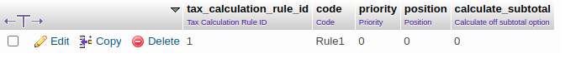

**sales_order :** Stores order-level tax information

|  |  |
| --- | --- |
| Column Name | Description |
|  |  |
| entity_id | Unique identifier for the order |
| tax_amount | Total tax amount applied to the order |
| base_tax_amount | Base currency total tax amount |
| shipping_tax_amount | Tax amount applied to the shipping fee |
| base_shipping_tax_amount | Base currency tax amount for shipping |
| discount_tax_compensation_amount | Compensation amount for tax after discounts |
| base_discount_tax_compensation_amount | Base currency compensation for tax after discounts |

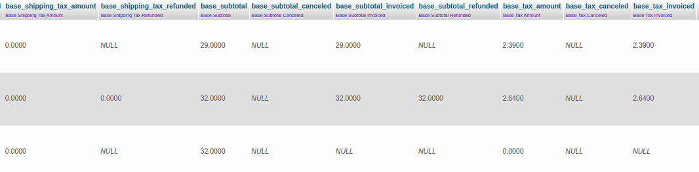

* When we are placing an order, the tax will be displayed in the order summary

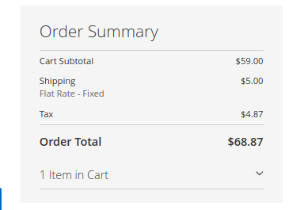

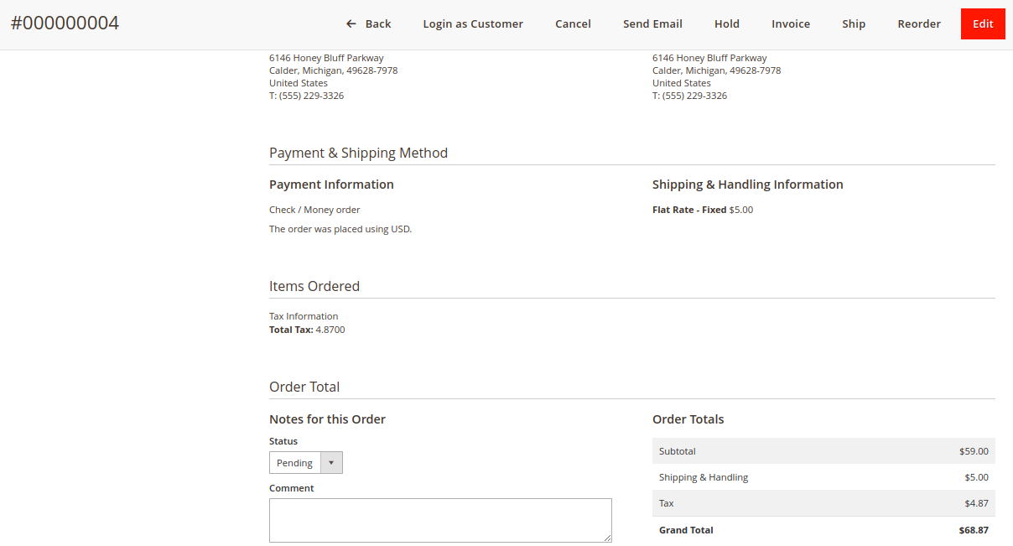

We can fetch tax information by using below instruction, I have created a module to display the tax information in the sales_order_view page

* Displayed tax information in sales order view page
* Block code extends Magento's order view items block to add a method for retrieving the tax amount of an order in the admin panel.
* Di.xml sets a preference to override Magento's default Order View Items block with the custom block Tychons\OrderTaxInfo\Block\Adminhtml\Order\View\Items.
* Module.xml declares a Magento 2 module named Tychons_OrderTaxInfo with a setup version of 1.0.0.
* The layout xml file updates the sales_order_view page by changing the template of the order_items block to Tychons_OrderTaxInfo::order/view/items.phtml.
* Phtml file displays the total tax amount in an admin HTML section titled "Tax Information."

-------------------------------------------------------------------------------------------------------------

**To set up Canada-based tax and GST in your Magento 2 Admin Panel**

**Configure Tax Calculation Settings**

**Navigate to Tax Settings:**

* From the Admin sidebar, go to **Stores** > **Settings** > **Configuration**.
* In the left panel, expand **Sales** and select **Tax**.
* If you're working on a multisite setup, select the appropriate **Store View** for the target store.

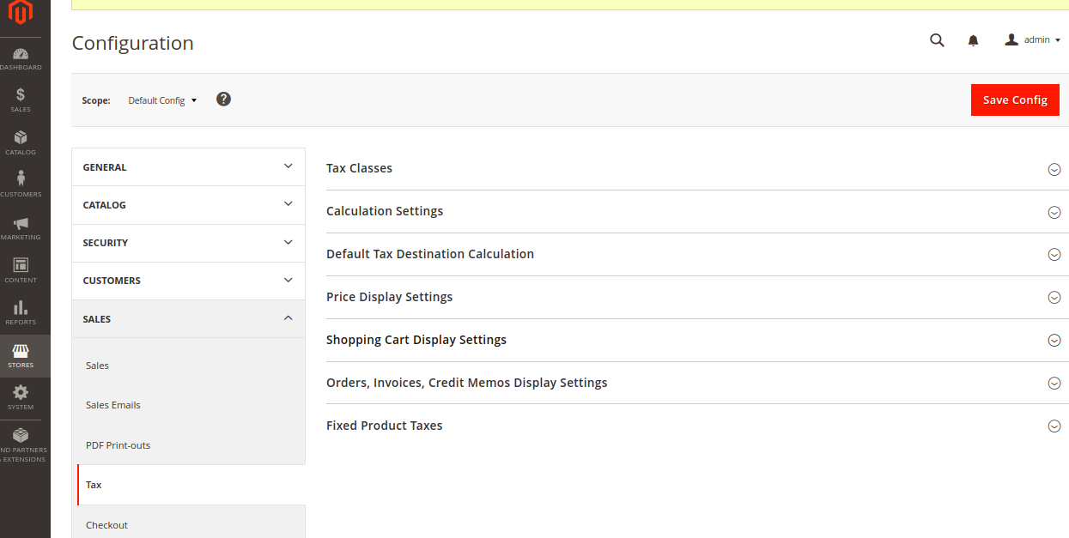

**Expand the Tax Calculation Settings**:

* Under **Tax Calculation Settings**, configure like the below one

|  |  |
| --- | --- |
| **Field** | **Recommended Setting** |
|  |  |
| Tax Calculation Method Based On | Total |
| Tax Calculation Based On | Shipping Address |
| Catalog Prices | Excluding Tax |
| Shipping Prices | Excluding Tax |
| Apply Customer Tax | After Discount |
| Apply Discount on Prices | Excluding Tax |
| Apply Tax On | Custom Price (if available) |

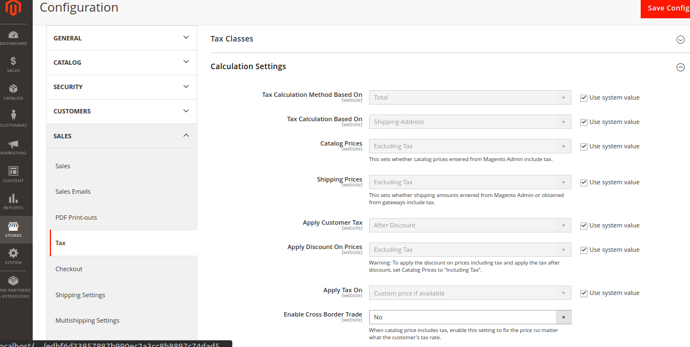

**Tax classes**

* Still under **Tax** settings, expand the **Tax Classes** section, and configure

|  |  |
| --- | --- |
| **Field** | **Recommended Setting** |
|  |  |
| Tax Class for Shipping | none |

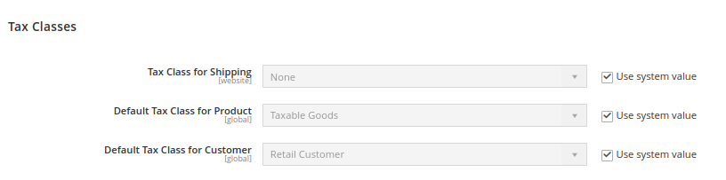

### **Set Default Tax Destination**

* Expand the Default Tax Destination Calculation section

|  |  |
| --- | --- |
| **Field** | **Recommended Setting** |
|  |  |
| Default Country | Canada |
| Default State | (as appropriate) |
| Default Postal Code | * (asterisk) |

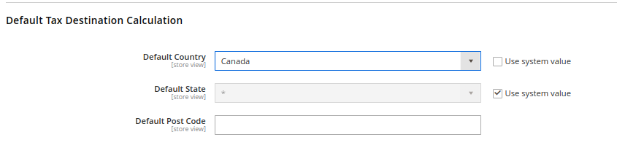

### **Configure Shopping Cart Display Settings**

Expand the Shopping Cart Display Settings section

|  |  |
| --- | --- |
| **Field** | **Recommended Setting** |
|  |  |
| Include Tax in Grand Total | Yes |
| Display Full Tax Summary | Yes |
| Display Zero in Tax Subtotal | Yes |

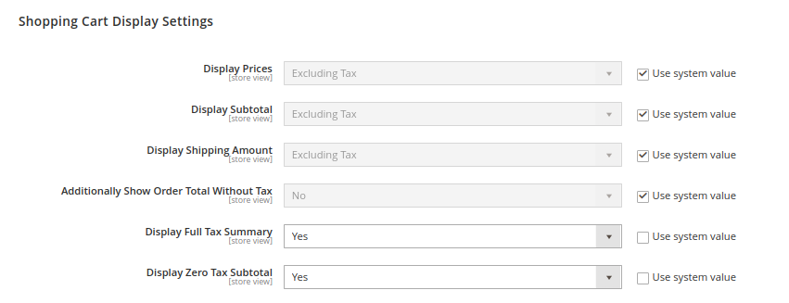

**Configure Fixed Product Taxes (FPT)**

* Expand the Fixed Product Taxes section

|  |  |
| --- | --- |
| **Field** | **Recommended Setting** |
|  |  |
| Enable FPT | Yes |
| All FPT display settings | Including FPT and FPT description |
| Apply Discounts to FPT | No |
| Include FPT in Subtotal | No |
| Apply Tax to FPT | Yes |

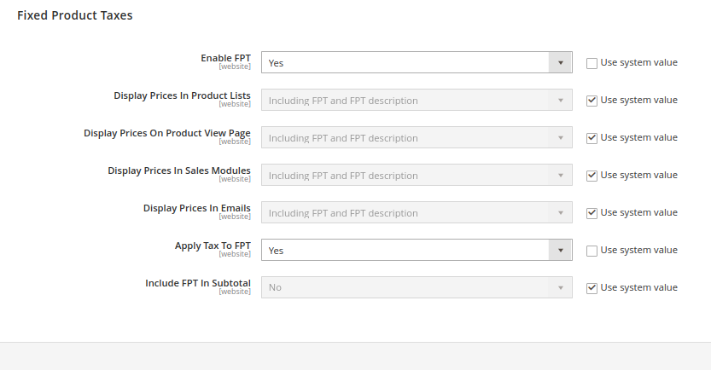

### **Set Up GST (Goods & Services Tax)**

* **Navigate to Manage Tax Zones & Rates**:
* Go to **Stores** > **Tax Zones and Rates**.
* **Create a New GST Tax Rate**:
* Click **Add New Tax Rate**.
* Click **Save Rate**.

|  |  |
| --- | --- |
| **Field** | **Recommended Setting** |
|  |  |
| Tax Identifier | Canada-GST |
| Country | Canada |
| State | * (asterisk) |
| Zip/Post is Range | No |
| Zip/Post Code | * (asterisk) |
| Rate Percent | 5.0000 |

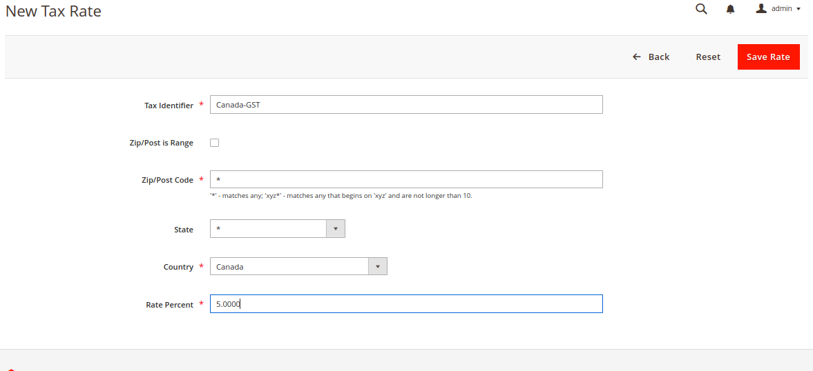

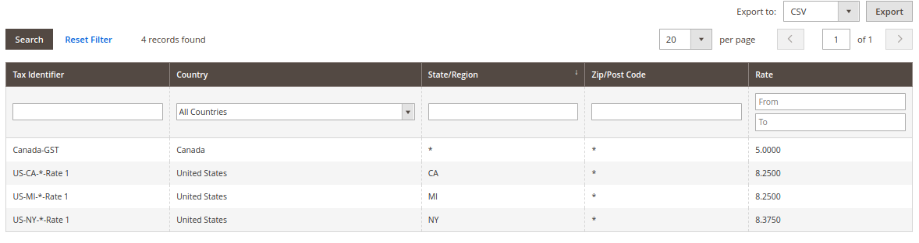

**Create GST tax rule**

* **Navigate to Tax Rules**:
* Go to **Stores** > **Tax Rules**.
* **Create the GST Tax Rule**:
* Click **Add New Tax Rule**.
* Click **Save Rule**

|  |  |
| --- | --- |
| **Field** | **Recommended Setting** |
|  |  |
| Name | Retail-Canada-GST |
| Customer Tax Class | Retail Customer |
| Product Tax Class | Taxable Goods |
| Tax Rate | Canada-GST |
| Calculate off subtotal only | Select this checkbox |
| Sort Order | 0 |

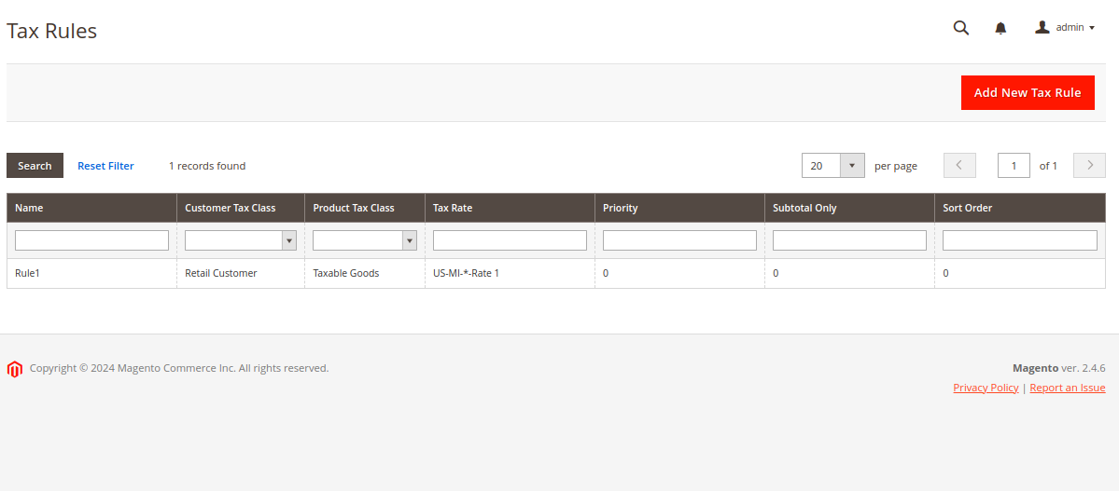

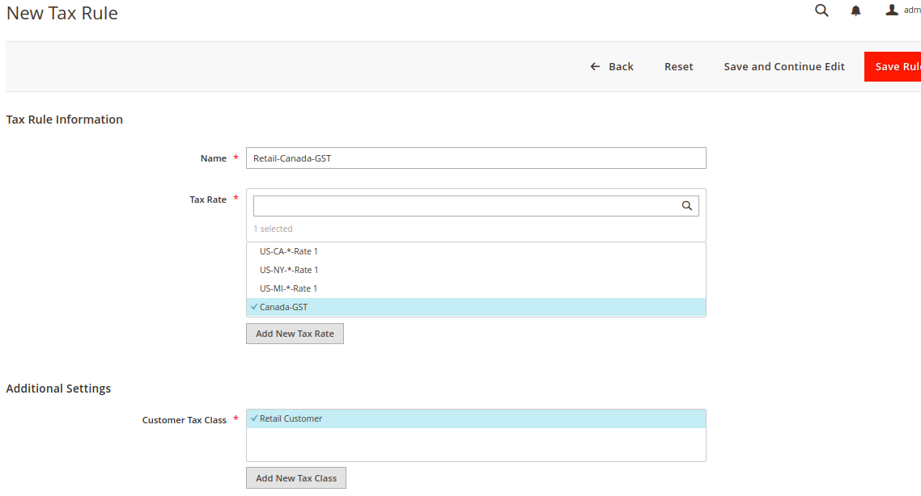

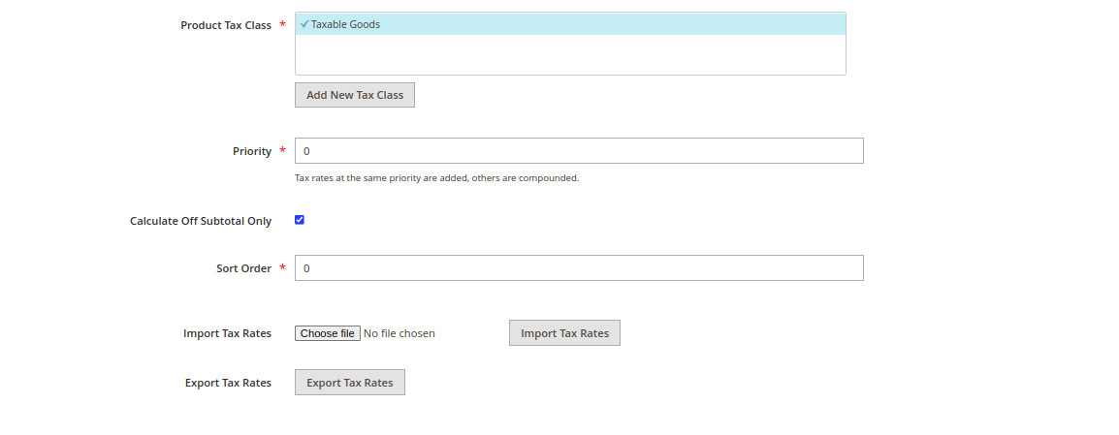

Final frontend output:

* Created a customer with sample Canada address

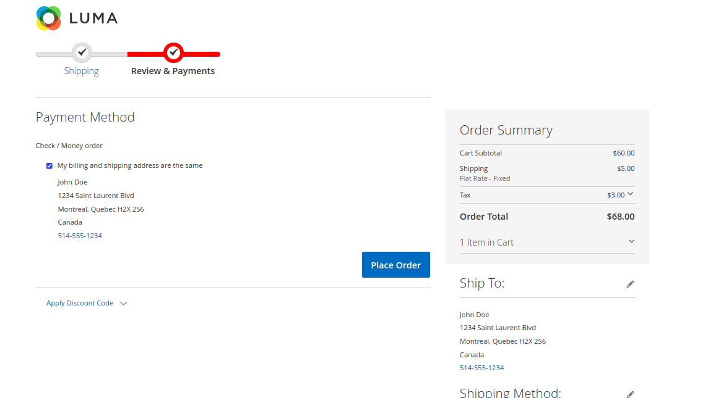

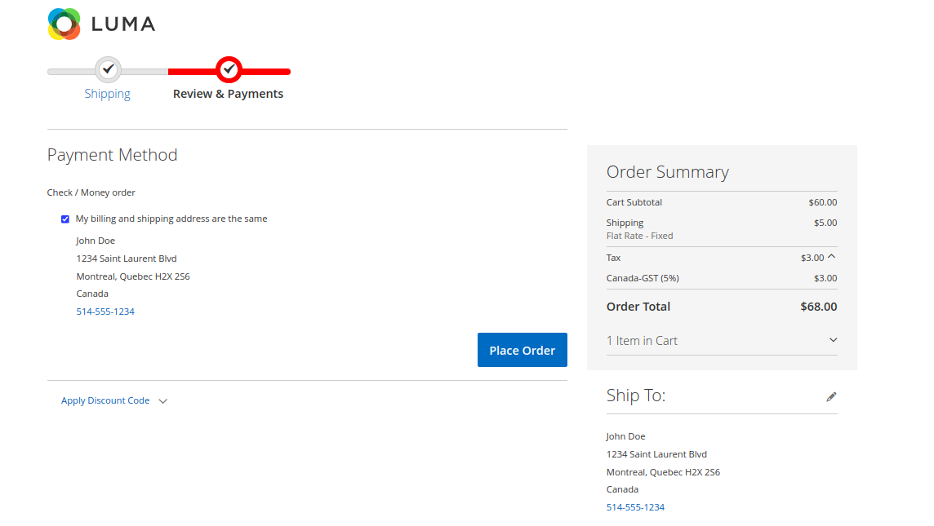

* It displays created canada-gst 5% in the order summary added amount

**Creating Canada-PST tax rule and tax rate:**

* **Navigate to Manage Tax Zones & Rates**:
* Go to **Stores** > **Tax Zones and Rates**.
* **Create a New PST Tax Rate**:
* Click **Add New Tax Rate**.
* Click **Save Rate**.

|  |  |
| --- | --- |
| **Field** | **Recommended Setting** |
|  |  |
| Tax Identifier | Canada-PST |
| Country | Canada |
| State | * (asterisk) |
| Zip/Post is Range | No |
| Zip/Post Code | * (asterisk) |
| Rate Percent | 7.0000 |

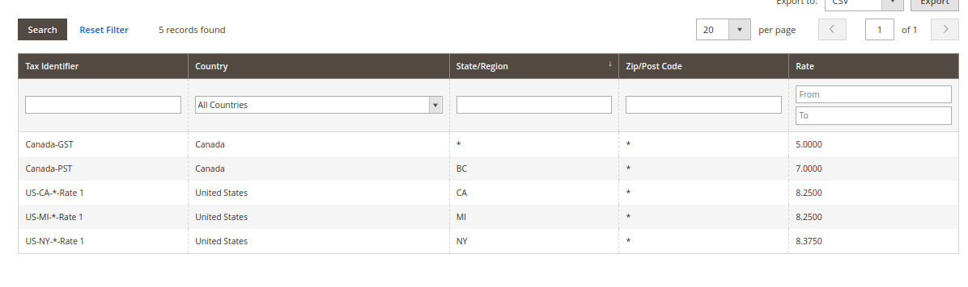

**Create GST tax rule**

* **Navigate to Tax Rules**:
* Go to **Stores** > **Tax Rules**.
* **Create the PST Tax Rule**:
* Click **Add New Tax Rule**.
* Click **Save Rule**

|  |  |
| --- | --- |
| **Field** | **Recommended Setting** |
|  |  |
| Name | Retail-Canada-PST |
| Customer Tax Class | Retail Customer |
| Product Tax Class | Taxable Goods |
| Tax Rate | Canada-PST |
| Calculate off subtotal only | Select this checkbox |
| Sort Order | 0 |

